
Rev E Engineering Review
PoE ESP32 Network Audio Endpoint — "PoE-Speaker-RevE"
Milestone | 1 of 3 — Rev E Engineering Review ($20)
Prepared by | El Amraoui @hamzaePCB
Date | September 25, 2026
Files reviewed | Files reviewed: GitHub Rev E KiCad project

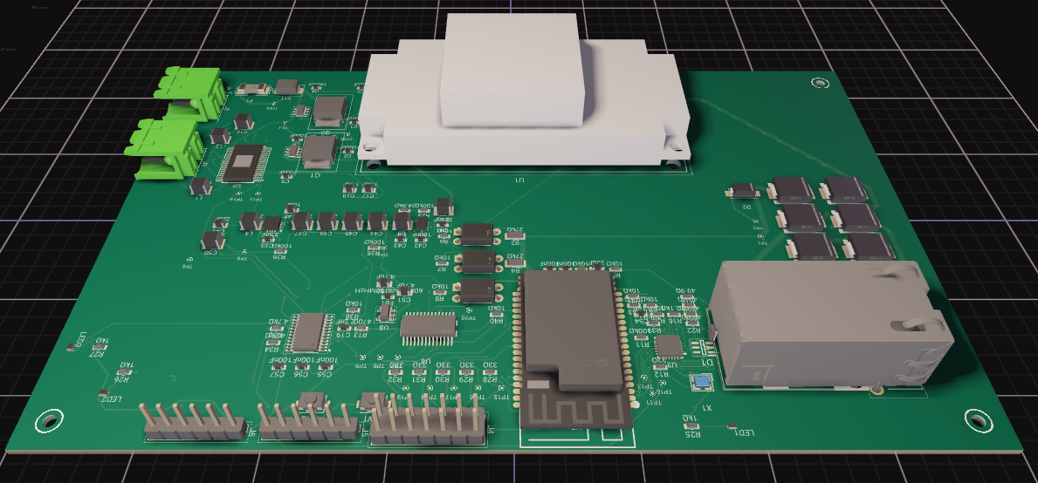

    - W5500 Ethernet MDI Pair (RX/TX) Routing
Priority: HIGH — Layout rework recommended during Milestone 2 before final impedance verification.
The Ethernet MDI routing between the W5500 (U3) and the Ethernet interface (J1) was reviewed visually in KiCad. The review confirms that the current RX and TX differential-pair routing should be refined before manufacturing release.
1. Reference-plane continuity — Verified
The ETH_TX_P/N and ETH_RX_P/N routing was visually checked against the In1.Cu ground plane. Although J1 extends outside part of the In1.Cu copper-pour boundary, the reviewed MDI routing remains over a ground-reference region along its signal path.
No specific rework is therefore recommended for this point based on the current visual inspection.
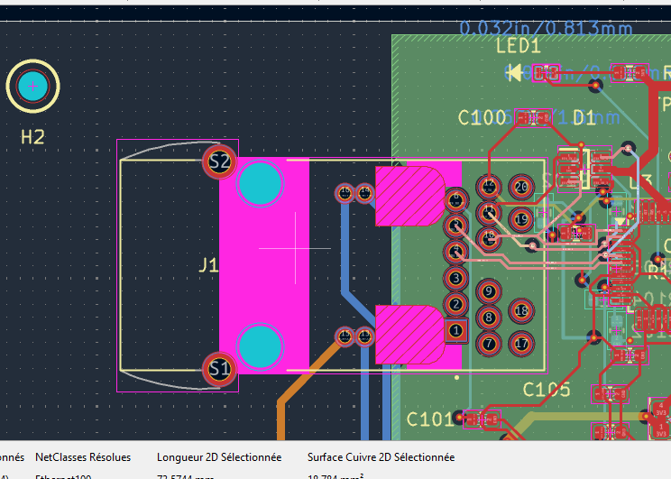
2. Differential-pair spacing and coupling
Both RX and TX pairs show sections where the P and N traces are separated significantly rather than remaining closely and consistently coupled.
This is particularly visible on ETH_RX_P/N, where the spacing changes substantially along the route. A similar condition is present on ETH_TX_P/N.
The pairs should be re-routed during Milestone 2 with more consistent P/N spacing and geometry. Final trace width and pair spacing should be determined from the selected fabrication stack-up rather than assumed from the current layout.
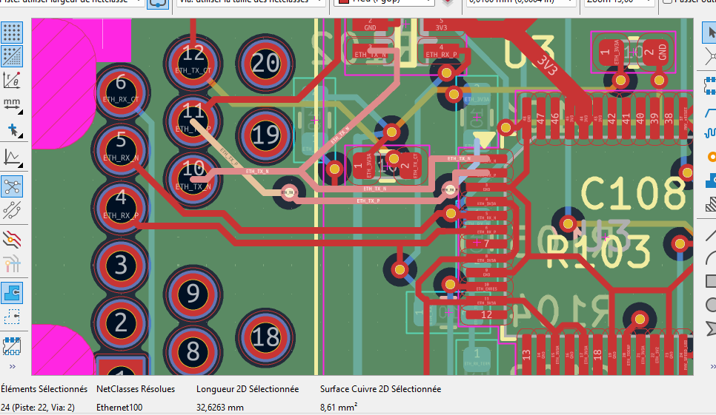
3. TX P/N layer-transition asymmetry
Visual inspection confirms that the two TX traces do not follow equivalent routing paths. ETH_TX_P contains additional layer transitions compared with ETH_TX_N; the P and N members therefore do not maintain mirrored layer transitions through the complete route.
For a differential pair, both traces should preferably follow the same layer sequence with corresponding vias placed together.
Recommendation: re-route ETH_TX_P/N as a coupled pair with symmetric layer transitions and matched via structures.
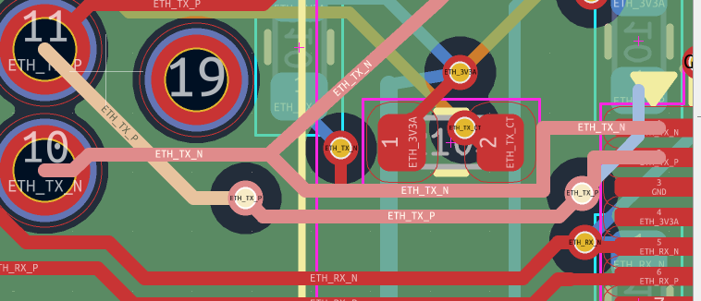
4. Intra-pair length / skew
Manual KiCad inspection confirms routing-length asymmetry between the P and N members. Exact full-net skew should be re-measured after re-routing.
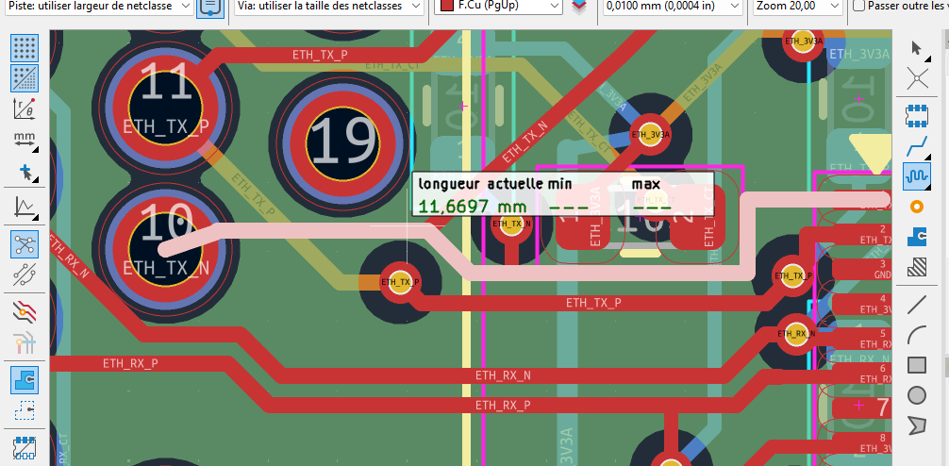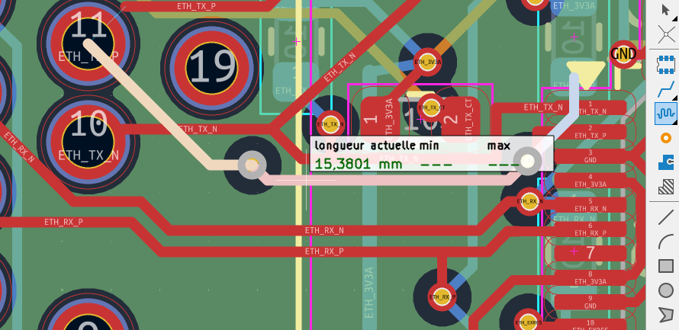
5. Track-width consistency and final impedance
The current Ethernet100 netclass defines a differential-pair width of approximately 0.2258 mm and a differential-pair gap of approximately 0.2032 mm. During visual inspection, however, existing MDI routing was found with both approximately 0.20 mm and 0.2258 mm track widths.
This indicates that the existing routed geometry is not fully consistent with the current netclass settings.
The board currently uses a 4-layer stack-up, but the final Ethernet geometry should be recalculated against the exact fabrication stack-up selected for production. The current width/gap values should therefore not be assumed to provide the final target differential impedance without verification.
Overall recommendation: During Milestone 2, re-route both ETH_RX_P/N and ETH_TX_P/N as true coupled differential pairs, maintain consistent spacing and width, use symmetric layer/via transitions, minimize P/N skew, preserve a continuous reference plane, and then verify the final differential impedance against the selected JLCPCB 4-layer stack-up.
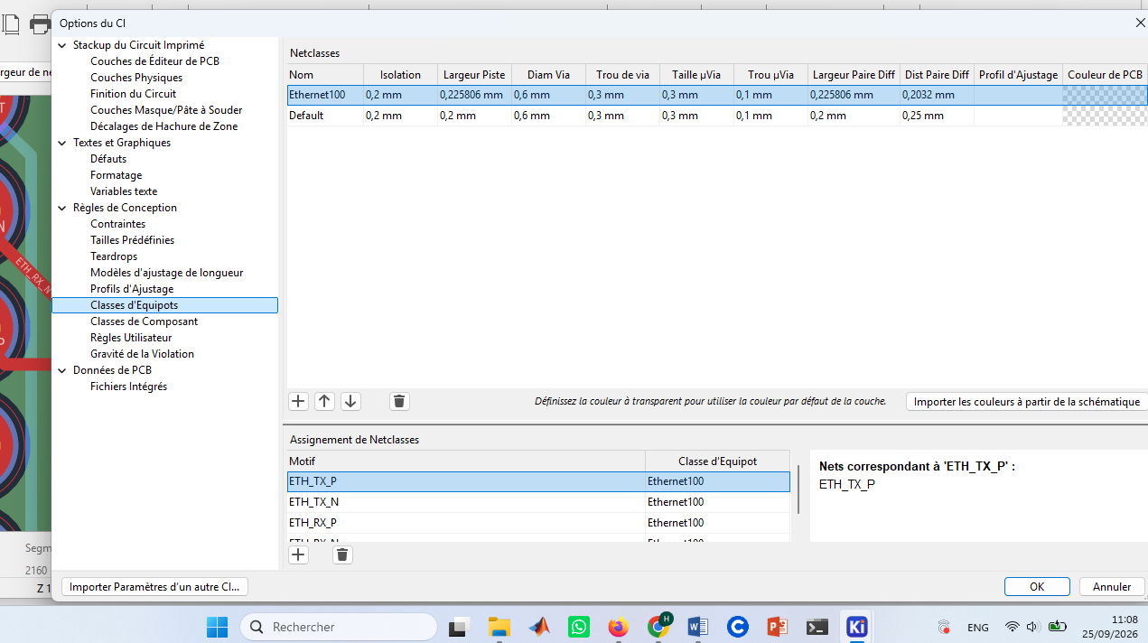
    - PCB Cleanup — Redundant GND Routing
Several GND pads are already connected directly to the ground copper plane, while additional long GND traces duplicate the same connection and consume routing space. These redundant traces should be removed during the Milestone 2 layout cleanup where no dedicated current-path requirement exists

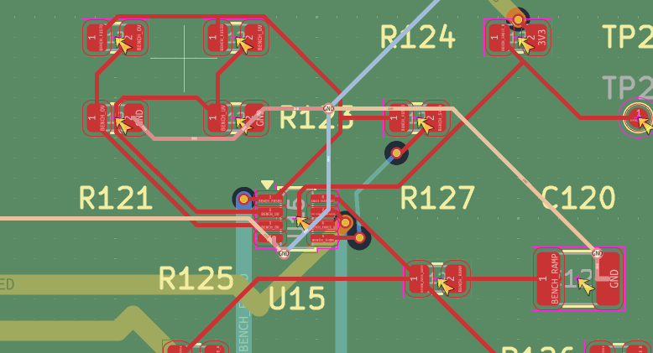
    - Amplifier Output-Limit Controls Are Currently Fixed
HIGH — Requires a design decision before implementing PoE-power-based output scaling in Milestone 2.
The client requires the speaker to reduce its maximum output when operating from a lower PoE power budget and to allow higher output when additional PoE power is available.
Review of the Rev E TPA3116D2 amplifier section confirms that the hardware gain and power-limit settings are currently fixed. AMP_GAIN is configured through R14 (5.6 kΩ) to GND, while AMP_PLIMIT is configured by R15 (82 kΩ), R16 (51 kΩ), and C58 (1 µF). No software-controlled switching or adjustment element was identified on either of these control networks.
AMP_MUTE is connected to the U11 I²C GPIO expander, providing controller access to the amplifier mute function. However, mute control does not provide dynamic adjustment of the existing AMP_GAIN or AMP_PLIMIT settings.
Recommendation: Before modifying the amplifier circuitry, determine how the ESP32 will identify the available PoE power budget (Finding B). Based on that result, PoE-dependent output scaling can either be implemented in firmware/DSP while retaining fixed amplifier settings, or through a hardware modification that provides selectable gain or power-limit settings.

IV . PoE Type Detection Hardware Is Already Implemented
POSITIVE / RECOMMENDATION — The existing Rev E hardware provides the required path for PoE-dependent power management.
The client requires the system to identify the available PoE source type so that the speaker output can be adjusted accordingly. Review of Rev E confirms that the required detection hardware is already implemented.
The Ag5800 provides three dedicated PSE type-detection outputs: AT-DET, TYP3-DET, and TYP4-DET. According to the manufacturer datasheet, no detection output is active with an IEEE 802.3af PSE, while AT-DET, TYP3-DET, and TYP4-DET indicate IEEE 802.3at, IEEE 802.3bt Type 3, and IEEE 802.3bt Type 4 respectively. In Rev E, these outputs are routed as AT_DET_PRIMARY, BT3_DET_PRIMARY, and BT4_DET_PRIMARY and cross the isolation barrier through U12, U13, and U14 optocouplers. This implementation is consistent with the Ag5800 datasheet recommendation for transferring PSE-type detection signals to the controller side.
On the isolated logic side, the resulting POE_AT_DET, POE_BT3_DET, and POE_BT4_DET signals are connected to U11 (PCAL6416APW) on pins 9, 10, and 11. U11 is connected to the controller through the existing I²C interface.
Recommendation: No additional hardware is required for PoE source-type detection. The existing detection path should be retained and used by the firmware to determine the applicable power-management state. This information can then be combined with the output-limiting strategy discussed in Finding A to implement PoE-dependent speaker output scaling.

V. Protected Dual-Source 24 V Power Path
POSITIVE / LOW — The overall power-path architecture is coherent and should be preserved.
Review of the Rev E power architecture confirms a protected dual-source path supplying the amplifier and downstream power conversion.
The bench-supply path is protected by U15 (LTC4365) and its external MOSFET stage. The circuit monitors the configured under-voltage and over-voltage thresholds and produces the protected 24V_BENCH_PROTECTED rail.
The PoE and protected bench rails are then combined through two LM5050-2 ideal-diode controllers. U9 connects 24V_POE to 24V_OR, while U10 connects 24V_BENCH_PROTECTED to the same 24V_OR rail, providing controlled source OR-ing.
The combined 24V_OR rail feeds U16 (TPS26630 eFuse). Its protection and control connections include under-voltage, over-voltage, current-limit, dV/dt, shutdown, fault, and power-good related signals. The protected output of U16 becomes 24V_AMP.
Finally, 24V_AMP directly supplies the U5 TPA3116D2 amplifier and the U6 LMR33630 buck converter used for the downstream 5 V power stage.
Recommendation: Preserve the existing power-path architecture. No architectural change is recommended at this stage. The passive protection thresholds, current-limit configuration, component ratings, and thermal margins should be checked separately during the detailed power-integrity review before manufacturing.

VI. Audio Signal Chain — Schematic Review
POSITIVE / VERIFICATION No additional critical schematic-level issue was identified in the reviewed PCM5122-to-TPA3116D2 audio chain.
The previously identified fixed AMP_GAIN and AMP_PLIMIT configuration remains the main audio-related design consideration and is addressed separately in Finding A.
Recommendation: Preserve the existing audio architecture. Class-D routing, grounding, EMI, and thermal performance should be verified during the Milestone 2 PCB layout review before manufacturing.

VII. ESP32-S3 Controller and RF Interface
POSITIVE / VERIFICATION No critical schematic-level issue was identified in the ESP32-S3 controller, boot, or programming interface.
The design uses an ESP32-S3-WROOM-1U-N16R8 module (U2), which is the external-antenna variant. The EN and GPIO0 boot-strapping circuits include dedicated pull-ups and manual RESET/BOOT switches, while J5 provides the required UART programming/debug signals together with EN and GPIO0 access.
Because U2 uses an external antenna connection rather than an integrated PCB antenna, the PCB-antenna keep-out requirement does not apply in the same way as for the ESP32-S3-WROOM-1 antenna variant.
Recommendation: Preserve the existing boot/programming architecture. During Milestone 2, verify/optimize local 3.3 V decoupling placement around U2 and ensure that the external antenna connector and coaxial-cable path remain mechanically accessible and separated from noisy power/Class-D circuitry.

VIII. PCB DRC Violations Require Resolution Before Manufacturing
HIGH — The current Rev E PCB is not DRC-clean and requires a dedicated layout cleanup before manufacturing release.
A KiCad DRC run on the current Rev E layout reports multiple errors and warnings, including short-circuit violations around the TPA3116D2 amplifier section, clearance violations below the configured 0.20 mm minimum, and remaining unconnected items.
Examples include reported shorts between GND and AMP_MUTE, and between AMP_SDZ and GND, together with clearance violations around the amplifier switching/bootstrap circuitry.
Recommendation: Review and resolve the reported DRC violations during Milestone 2, prioritizing shorts, unconnected items, and minimum-clearance violations. Intentional or footprint-related violations should be individually verified and excluded only when technically justified. After the layout corrections, refill all copper zones and run a final clean DRC before generating the manufacturing package
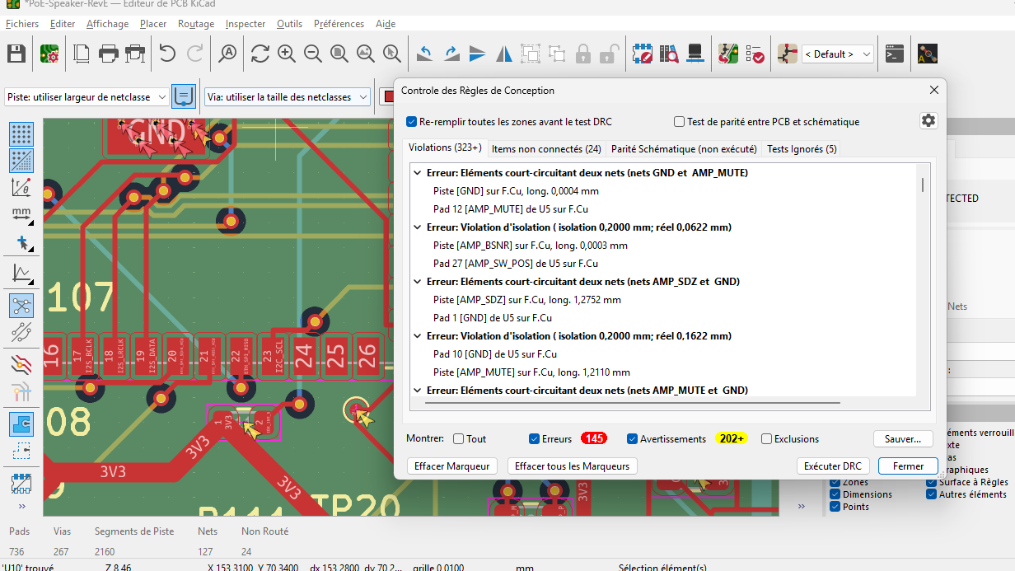
Summary of Design Review Findings
ID | Area | Finding | Priority / Next Step
A | Amplifier control (U5) | AMP_GAIN and AMP_PLIMIT are currently fixed by passive networks. AMP_MUTE is controller-accessible through U11, but no direct software-adjustable GAIN/PLIMIT path was identified. | Design decision — define PoE-dependent output-limiting strategy for Milestone 2
B | PoE detection (U1/U11–U14) | Ag5800 AT/Type-3/Type-4 detection signals are optically isolated and connected to U11 for controller access over I²C. | Positive — retain and use
C | W5500 MDI routing (J1–U3) | MDI pairs show non-uniform coupling/spacing, inconsistent trace widths, and TX P/N routing/layer-transition asymmetry. Continuous GND reference was visually confirmed. | High — rework during Milestone 2
D | 24 V power path | Bench protection, dual-source LM5050-2 OR-ing, TPS26630 eFuse, and distribution to the amplifier/buck were confirmed. | Positive — preserve architecture; verify limits/ratings separately
E | Stack-up / impedance | Current PCB uses a 4-layer stack-up. Final Ethernet impedance must be checked against the exact selected JLCPCB production stack-up. | Verification before manufacturing
F | GND routing cleanup | Several locations contain explicit GND traces where pads are already connected through GND copper, creating potentially redundant routing. | Layout cleanup — review during Milestone 2

G | PCB DRC | Current Rev E layout reports short-circuit violations, clearance violations, and remaining unconnected items | HIGH — Resolve during Milestone 2 and achieve a clean DRC before manufacturing.
Recommended Next Steps
• Define the final PoE-dependent speaker output-limiting strategy using the already available PoE-type detection signals.
• Rework the W5500 Ethernet MDI routing to maintain consistent differential-pair geometry, width, spacing, and symmetric P/N routing.
• Confirm the final JLCPCB four-layer production stack-up and verify the Ethernet differential impedance against that stack-up.
• Review and clean up redundant GND routing where the existing ground plane already provides the required connection.
• Verify protection thresholds, current limits, component ratings, and thermal margins in the 24 V power path.
• Resolve the current DRC shorts, clearance violations, and unconnected items during Milestone 2, then achieve a clean final ERC/DRC before generating the Milestone 3 manufacturing package.

